Order Of Service

Singing: Psalm 18—CW page 69

Reading: Psalm 18:7-15

Opening Hymn: TLH 422

Reading: Revelation 2:8-11

Request Hymn: CW Supplement 752

Reading: John 3:31-36

Sermon Hymn: TLH 421

Sermon Text: Song Of Solomon 4:8

Come With Me !

Prayer

The Apostles’ Creed, TLH page 12

Holy Communion

The Lord's Prayer

The Blessing

Closing Hymn: TLH 52

* * * * * * * * * * *

Koinonia Hour

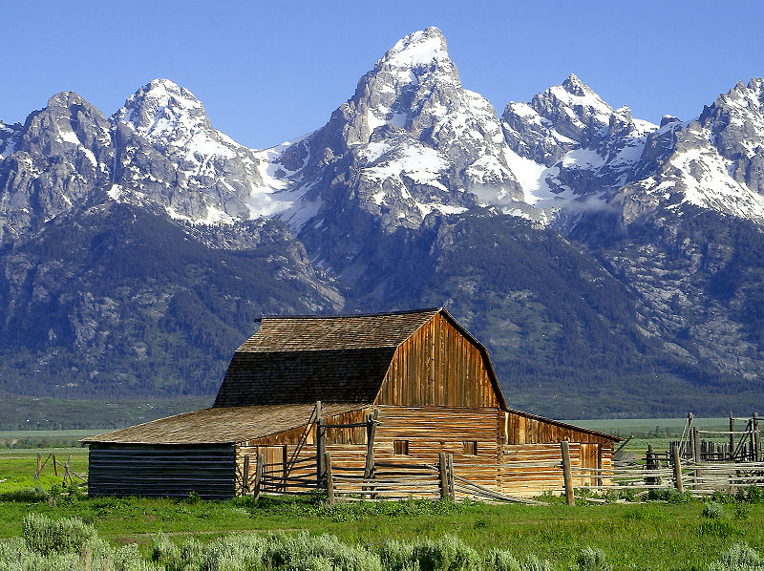

Mountain Range

Water
Of
Life

4 September 2016

W A T E R O F L I F E

Independent Christian Church—Conservative Lutheran Doctrine

Worship Service: 9:30 a.m. Bible Study: 10:45 a.m.

Larry Cooper, Pastor E-Mail address:
111 N. Ridge Road lcooper@wateroflife.cc
Coon Valley, WI 54623 Web Site:
Phone: (608) 452-2105 www.wateroflife.cc

* * * * * * * * * * * * * * * * * * * * * * * * * * *

Sermon Text: Song Of Solomon 4:8

Come With Me !

* * * * * * * * * * * * * * * * * * * * * * * * * * *

Song of Solomon 4:8 Come with me from Lebanon, my spouse, with me from Lebanon: look from the top of Amana, from the top of Shenir and Hermon, from the lions' dens, from the mountains of the leopards.

* * * * * * * *

Immediately after Jesus was baptized, Matthew tells us: Matthew 4:1 “Then was Jesus led up of the Spirit into the wilderness to be tempted of the devil.”

The third and final temptation at that time is recorded in Matthew 4:8-11.

Matthew 4:8 Again, the devil taketh him up into an exceeding high mountain, and sheweth him all the kingdoms of the world, and the glory of them;
:9 And saith unto him, All these things will I give thee, if thou wilt fall down and worship me.
:10 Then saith Jesus unto him, Get thee hence, Satan: for it is written, Thou shalt worship the Lord thy God, and him only shalt thou serve.
:11 Then the devil leaveth him, and, behold, angels came and ministered unto him.

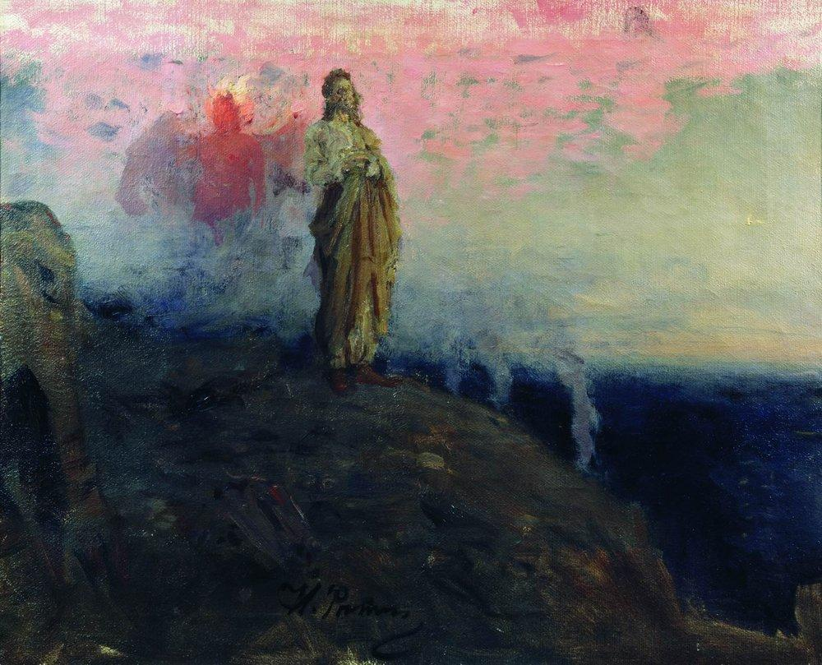

Satan tries the same tactic against the Bride of Jesus Christ. Notice the names of the beautiful mountains here in Song Of Solomon 4:8. Lebanon – Amana – Shenir – Hermon – beautiful mountains all. But there is danger there in the midst of all the beauty. Lions and leopards are not friendly to the Lord’s Bride. So he calls her to come away from the beauty of this world, and to be with him in his Kingdom of Glory.

